THE NEW ZEALAND WINE INDUSTRY

The wine industry in New Zealand is performing very well. According to the *New Zealand Winegrowers Annual Report*, one billion glasses of NZ wine were sold worldwide in 2007. In the same year, total sales of New Zealand wines were a staggering 127 million liters, of which 76 million liters were exports. This represented a 36% increase in total export value and total sales of $1.2 billion.

However, the industry has not been without its challenges. Fierce competition with Australian wine, supply constraints from local New Zealand producers, and a strong New Zealand dollar have all taken their toll.

Notwithstanding these current problems, according to the Wine Institute of New Zealand, the future is bright with predicted exports of $1 billion in 2010 and predicted sales of $0.5 billion at profitable prices.

**Discussion**

1. Members of the New Zealand wine industry are interested in trying to predict both domestic and export sales. It is probable that domestic consumption of New Zealand wine is affected by the availability of wines produced in other countries. In particular, given the high quality and affordability of its wines, imports from Australia could have an adverse effect on domestic consumption of New Zealand wine. The following data relate to consumption per capita (in liters) of New Zealand wine and wine imports from Australia (in million of liters) for the years ended June 1997 to 2007. Use the multiple regression analysis techniques to analyze the data. Include both regression and correlation techniques. Discuss the strength of the relationship and any models that are developed.

|  |  |  |
| --- | --- | --- |
|  | **Consumption per capita (liters NZ wine)** | **Wine imports from Australia (millions liters for the year ended June)** |
| 1997 | 10.4 | 16.201 |
| 1998 | 10.1 | 21.772 |
| 1999 | 10.1 | 20.762 |
| 2000 | 10.6 | 20.655 |
| 2001 | 9.3 | 21.331 |
| 2002 | 8.2 | 25.091 |
| 2003 | 8.8 | 32.363 |
| 2004 | 8.8 | 27.636 |
| 2005 | 11.2 | 24.340 |
| 2006 | 12.1 | 27.250 |
| 2007 | 12.2 | 36.497 |

1. Suppose, realistically, that the New Zealand government and wine industry are keen to predict export sales of New Zealand wine with a view to increasing future export sales. Many of the factors that determine exports will be out of the hands of both the wine industry and the government. However, one major factor that will

help determine export volumes will be the total productive capacity of the New Zealand wine industry. The following data, also taken from the *New Zealand Winegrowers Annual Report 2007*, relate to export volumes of New Zealand wine (millions of liters) and the number of wineries in New Zealand over the financial years (ending June) 1997 to 2007. Using these data and the multiple regression techniques, write a brief report to the New Zealand government about the predictability of export sales from the number of wineries. In this report, in light of your results, state how it might (or might not) be possible to increase export sales in the future.

|  |  |  |
| --- | --- | --- |
|  | **Number of Wineries** | **Export Volume (millions of liters)** |
| 1997 | 262 | 13.1 |
| 1998 | 293 | 15.2 |
| 1999 | 334 | 16.6 |
| 2000 | 358 | 19.2 |
| 2001 | 382 | 19.2 |
| 2002 | 398 | 23.0 |
| 2003 | 421 | 27.1 |
| 2004 | 463 | 31.1 |
| 2005 | 516 | 51.4 |
| 2006 | 530 | 57.8 |
| 2007 | 543 | 76.0 |

1. Suppose that, at least in the short run, the number of wineries is fixed. It might be possible to increase total production of New Zealand wine by improving the average grape yield of the existing wineries. Data from the same source, on average yield in tonnes per hectare and total wine production in millions of liters, is provided in the following table. Using multiple regression techniques, do you believe that it is possible to adequately predict total wine production by average yield? Explain.

|  |  |  |
| --- | --- | --- |
|  | **Total Wine production (millions of liters)** | **Average yield (tonnes per hectare)** |
| 1997 | 45.8 | 8.1 |
| 1998 | 60.6 | 10.3 |
| 1999 | 60.2 | 8.9 |
| 2000 | 60.2 | 7.8 |
| 2001 | 53.3 | 6.1 |
| 2002 | 89 | 8.6 |
| 2003 | 55 | 4.8 |
| 2004 | 119.2 | 8.9 |
| 2005 | 102 | 6.9 |
| 2006 | 133.2 | 8.2 |
| 2007 | 147.6 | 8.1 |

1. Domestic sales of New Zealand wine have reached their highest level ever, with 51 million liters of wine sold in 2007. Government policies have also been put in place to support the industry and achieve sustained growth. However, an important question is whether, ultimately, there is enough land devoted to grape cultivation, since the quantity of grapes crushed predominantly determines how much wine is produced. Therefore, it might be useful to investigate the relationship between domestic sales of wine and area of land devoted to wine production. The following excel output displays the results of a regression predicting domestic sales of New Zealand wine (in millions of liters) by producing area (in hectares). Suppose you were asked by the Wine Institute of New Zealand to analyze this data and write a brief report. Based on the results below, what would you find?

|  |  |  |  |  |  |  |
| --- | --- | --- | --- | --- | --- | --- |
| SUMMARY OUTPUT |  |  |  |  |  |  |
|  |  |  |  |  |  |  |
| *Regression Statistics* | |  |  |  |  |  |
| Multiple R | 0.658102884 |  |  |  |  |  |
| R Square | 0.433099406 |  |  |  |  |  |
| Adjusted R Square | 0.370110451 |  |  |  |  |  |
| Standard Error | 4.801382127 |  |  |  |  |  |
| Observations | 11 |  |  |  |  |  |
|  |  |  |  |  |  |  |
| ANOVA |  |  |  |  |  |  |
|  | *df* | *SS* | *MS* | *F* | *Significance F* |  |
| Regression | 1 | 158.5096579 | 158.5097 | 6.875799 | 0.027712 |  |
| Residual | 9 | 207.479433 | 23.05327 |  |  |  |
| Total | 10 | 365.9890909 |  |  |  |  |
|  |  |  |  |  |  |  |
|  | *Coefficients* | *Standard Error* | *t Stat* | *P-value* | *Lower 95%* | *Upper 95%* |
| Intercept | 30.85590683 | 3.849536982 | 8.015485 | 2.18E-05 | 22.14765 | 39.56416 |
| Producing Area | 0.000633111 | 0.000241445 | 2.622175 | 0.027712 | 8.69E-05 | 0.001179 |

1. let the consumption per capital be x an wine imports from Australia be y

Then,the correlation between the two variable an given by,

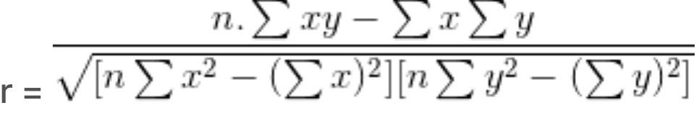=0.1683

As the correlation coefficient is positive,we can not say that imports from Australia have an adverse effort on domestic consumption of New Zealand wine.we can sat that both the variables have a moderate positive relationship.

If we calculate the regression equation foe this data,assuming consumption per capital as dependent variable,then the intercept and the coefficient can be calculated by,

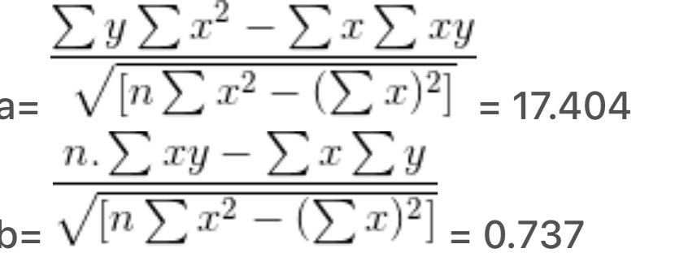

And the equation can be given by

Y=17.404+0.737x

Here also,we can see that the coefficient of x variable is positive,which means we can not say that imports from Australia have an adverse effect on domestic consumption of New Zealand wine.both the variables increases or decreases at the same time.